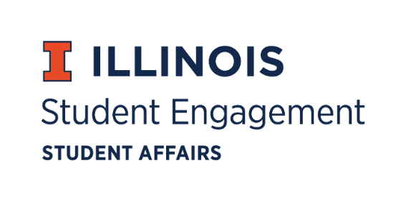
Student Organization
Resource Fee
SORF Meeting
Thursday, March 24, 2022 at 5:00PM
Student Org Complex
Call to Order:
Michael Isaacson calls meeting to order at 5:07pm.

Roll Call:
Present:
- Michael Isaacson, Chairperson
- Alex Wang, Vice-Chairperson
- Umar Ahmed, SORF Treasurer
- Jimmy Song, Undergraduate Board Member
- Nico Perez, Undergraduate Board Member
- Inaaz Mirza, Undergraduate Board Member
- Ashley Winters, Undergraduate Board Member
- Damian Chavez, Undergraduate Board Member
- Brian Farber, Faculty/Staff Board Member
- Nick Fink, SORF Advisor (non-voting member)
- Christina Fraser, SORF Secretary (non-voting member)
Absent:
- Stephanie Cardoza-Cruz, Faculty/Staff Board Member
- Sheri Idris, SORF Financial Secretary (non-voting member)
03/24/22 Meeting Agenda:
- Review of Tabled Applications
- Large Scale Programming Applications
- Standards Review Update
- Apparel Discussion

Approval of 03/10/22 minutes:
Michael Isaacson approves by unanimous consent.

Approval of 03/24/22 Agenda:
Michael Isaacson approves by unanimous consent.

Old Business:

Tabled Applications, Review Period 2, 3/10/22- 5/31/2022:

App Number | Funding Type | RSO Name | Amount Requested | Amount Allocated | Vote
137734 | Projects | Korean Liberal Arts Student Organization | $149.97 | $120.00 | 7-0-0

- App No. 137734- Korean Liberal Arts Student Organization
  - Description: Subscription to the Financial Times and Bloomberg for a report.
  - Reviewer’s notes: RSO is requesting funding for access to sites (access to information) that allow them to complete project - leading markets presentation.
  - Funding type: Projects
  - Amount Requested: $149.97
  - Amount Allocated:
  - Meeting notes: Jimmy Song motions to approve at standard. Umar Ahmed seconds. Vote of 7-0-0.
  - Update: SORF board revoted due to UIUC having free subscription of Bloomberg available for students. Umar Ahmed motions to zero fund line item two. Alex Wang seconds. Vote of 7-0-0.

New Business:

Large Scale Programming Applications:

App Number | Funding Type | RSO Name | Amount Requested | Amount Allocated | Vote
145098 | Large Scale Programming | Lambda Theta Alpha Latin Sorority, Incorporated. | $20,237.20 | $20,237.20 | 7-0-0
145499 | Large Scale Programming | Korean Student Association | $10,205.39 | $0.00

- App No. 145098- Lambda Theta Alpha Latin Sorority, Incorporated; Planned Parenthood Generation Action
  - Description: This event, O.L.A.S (Olas de Lucha, Alianza, y Sovrevivencia - Waves of Resilience, Allyship, and Survival) Gala and Candlelight Vigil, is banquet-style event to honor, validate, and heal from the hurt that sexual assault generates within our community. RSO is requesting food, rental space (Alice Campbell Alumni Center), consumable supplies, and contractual service fees related to the event.
  - Funding type: Large scale programming
  - Amount requested: $20,237.20
  - Amount allocated: $20,237.20
  - Meeting notes: Alex Wang motions to approve application at standard. Umar Ahmed seconds. Vote of 7-0-0.
- App No. 145499- Korean Student Association
  - Description: K-Week is a large scale event held by Korean Student Association with KLASO during the 3rd week of April, which Korean students but also UIUC students who are interested in Korean culture can join all Korean cultural events.
  - Funding type: Large scale programming
  - Amount requested: $10,205.39
  - Amount allocated: $0.00
  - Meeting notes: Alex Wang motions to adjust line item 8 because one of the requested items is permanent equipment. Umar Ahmed seconds. Vote of 7-0-0. Umar Ahmed motions to zero fund line items 5 and 9 because they are permanent equipment. Brian Farber seconds. Vote of 7-0-0. Application denied because it fell below the $10,000.00 minimum required for large-scale programming requests.

For the good of the order:

Adjournment:
Meeting adjourned at 6:26pm.

