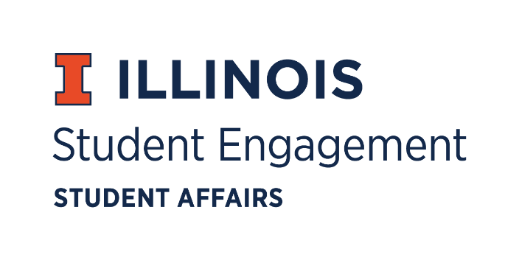

***Student Organization***   
***Resource Fee***

**SORF Funding Standards Review Meeting**

Saturday August 15, 2020 at 2:00PM

*Microsoft Teams*

**Call to Order**

2:04PM

**Roll Call**

Present

Jimmy Song, *Chairperson*

Omer Mirza, *Vice Chairperson*

Nico Perez, *Treasurer*

Alex Wang, *Undergraduate Board Member*

Adam Peterson, *Undergraduate Board Member*

Michael Isaacson, *Undergraduate Board Member*

Zachary Becker, *Undergraduate Board Member*

Bilal Shahid, *Undergraduate Board Member*

Jasmine Cuasay, *Secretary*

Nick Fink, *Staff Board Member*

Gina Lee- Olukoya, *Associate Dean of Students*

James Hintz, *Associate Vice Chancellor for Student Success & Engagement*

Alex Suñe, *Interim Program Advisor Associate Director, Student Success & Engagement*

**Funding Standards Review**

* Tackling barriers to funding
* Priority system model
  + Programs that have the most benefit to the campus community are prioritized
  + Some organizations primarily geared to non- event impacts
  + Consider unprecedented circumstances
    - How will events be held in the fall?
    - Campus impact will not be the same from past years
    - Favoritism towards certain organizations
  + Setting precedent in line with student body vote
* Languages of guidelines should be looked over
  + Contradictions
  + Passive language
  + Tracking equipment
  + Travel
  + Honorariums and spending
* Club Sports
  + How should club sports be funded?
* Reluctant to make sweeping changes in the upcoming fall semester
  + Standards set for a normal vs abnormal semester?
* 1.1Mil Surplus
* Consistency
  + Lacked with ambiguity in the guidelines
* How much and what should RSOs fund for themselves?
* How would the student body respond to SORF decisions/ changes?
* Uncertainty, inability to vote at this time

**Meetings Set Up**

Thursday 5PM meetings

In person/ remote?

**Adjournment**

3:01PM